11.2 Editors - Compositor Editor - Tool Shelf
Tool Shelf 2
Select Tools Group 2
Tweak 2
Select Box 2
Tool Settings 2
Mode 2
Set a new selection 2
Extend existing selection 2
Subtract existing selection 2
Select Circle 2
Tool Settings 3
Mode 3
Set a new selection 3
Extend existing selection 3
Subtract existing selection 3
Radius 3
Select Lasso 3
Tool Settings 3
Mode 3
Set a new selection 3
Extend existing selection 3
Subtract existing selection 3
Annotate Tools group 3
Annotate 4
Tool Settings 4
Color 4
Stabilize Stroke 4
Radius 4
Factor 4
Annotate Line 4
Tool Settings 4
Color 4
Style Start 4
End 5
Annotate Polygon 5
Tool Settings 5
Color 5
Annotate Eraser 5
Tool Settings 5
Radius 5
Links Cut 5

Tool Shelf

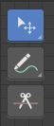

Select Tools Group
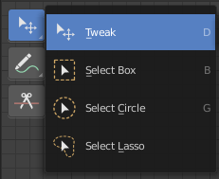
Tools with a triangle down right are a group of tools. Click and hold to reveal the content. Then choose the tool that you need.

Tweak
Allows you to select or tweak single elements by clicking at it.

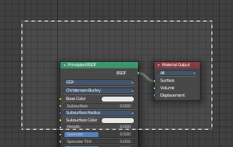
Select Box
Draws a box to select several elements at once. Click at the start point, then drag.

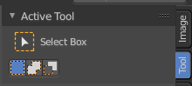
Tool Settings

Mode
The available selection modes. The mode titles are pretty self explaining. So i won't go into detail here.

Set a new selection

Extend existing selection

Subtract existing selection

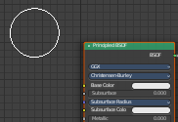
Select Circle
Draws a box to select several elements at once. Click at the start point, then drag.

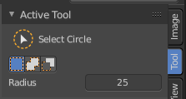
Tool Settings

Mode
The available selection modes. The mode titles are pretty self explaining. So i won't go into detail here.

Set a new selection

Extend existing selection

Subtract existing selection

Radius
The brush radius.

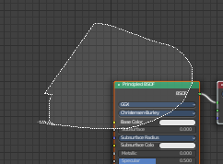
Select Lasso
Draws a box to select several elements at once. Click at the start point, then drag.

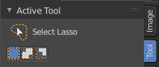
Tool Settings

Mode
The available selection modes. The mode titles are pretty self explaining. So i won't go into detail here.

Set a new selection

Extend existing selection

Subtract existing selection

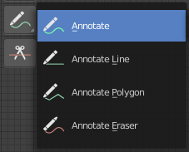
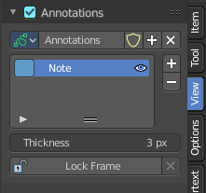
Annotate Tools group
The annotation tool is available in multiple editors. With this tool you can write notes at the screen. The annotate tools is the little brother of the grease pencil objects.
Further settings for annotate can be found in the sidebar. Here you can also remove an annotation when you don't longer need it. And here you can also adjust the size of the stroke.
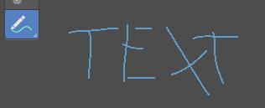

Annotate
Draw free-hand strokes in the main window.

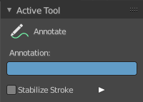
Tool Settings
The tool settings for Annotate.

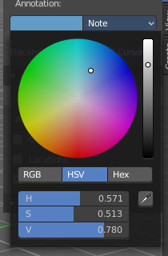
Color
Clicking at the left color field reveals a color picker. Define the color for the annotation stroke.

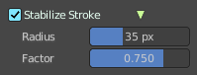
Stabilize Stroke
Helper to draw smooth and clean lines. Pressing shift inverts the effect.

Radius
The radius for the stroke stabilization.

Factor
Stabilizer stroke factor. Higher values gives a smoother stroke.

Annotate Line
Click and drag to create a line.

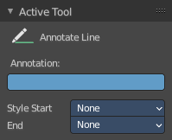
Tool Settings
The tool settings for the Annotate tool.

Color
Clicking at the left color field reveals a color picker. Define the color for the annotation stroke.

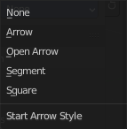
Style Start
The stroke start style. With an arrow for example you place an arrow at the start of the stroke.

End
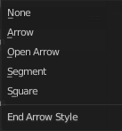
The stroke end style. With an arrow for example you place an arrow at the end of the stroke.

Annotate Polygon
Click multiple times to create multiple connected lines. The current polygon is finished when Esc or RMB is pressed.

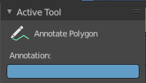
Tool Settings
The tool settings for Annotate.

Color
Clicking at the left color field reveals a color picker where you can define the color for the annotation stroke.


Annotate Eraser
Click and drag to remove annotate lines.

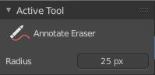
Tool Settings

Radius
The radius of the eraser pencil.

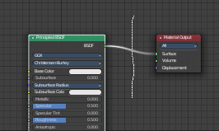
Links Cut
This tools allows you to cut connections.

